CST 326 – Game Development

Project 2 - Platformer (Part 1)

California State University Monterey Bay

Objective:

This week we are shifting to working on a more complex game with a platformer. From here we are going to look at rebuilding the iconic Mario Level 1-1 and introducing a way to approach iterating on level design. Along the way we are going to look at incorporating the items we learned from project 1 and applying them to this project. Additionally, we are going to start adding in different materials and textures.

SUBMISSION: FORMAT AND RULES

(Part 1) You have until Sunday, 11:59:30 PM to upload your solution for Project 2a. “Uploading” consists of sending the URL for your Git repository (if it’s public you don’t have to add me).

(Part 2) Upload the link from your screen captured video (should be an ‘unlisted’ video in YouTube in your profile) with you explaining your code (should be <5 minutes).

The total value of this activity: 40 bonus points

Implement the following in your game:

(10 Points) Complete the “Level Parser” to take the provided text document and parse it into the physical level (example below)

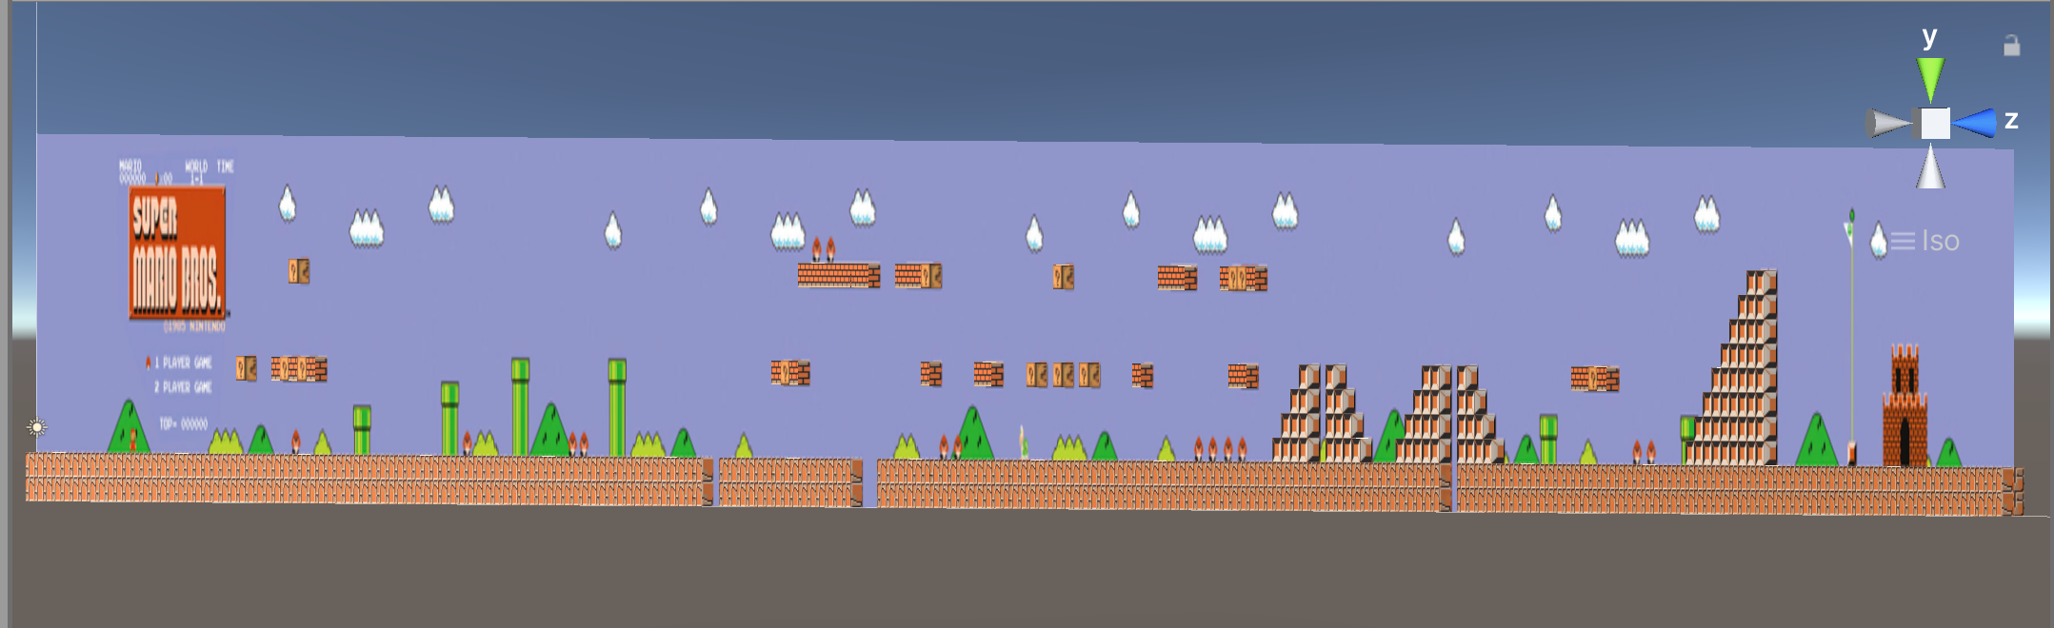

(10 Points) Materials

* +3 points - assigning a custom material to each type of block (e.g., rock, brick, ‘?’)
* +3 points - assigning a single texture to each material (e.g., a ‘?’ texture in the ‘?’ material)
* +4 points - assigning a cube map texture to a material

(5 Points) GUI - Keeping track of points, coins, time left in the level

* +3 Add spots for each category on the UI roughly mirroring the reference
* +2 Implement a time count down from start to complete the level (must count down at start) (Recommend looking at TimeSpan and DateTime (System)

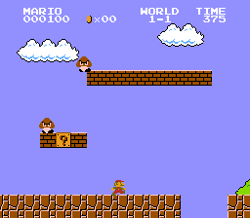

Reference

(5 points) Implement Physics.Raycast to start testing breaking apart bricks and hit coins by using a mouse click (i.e., click on the brick, it breaks apart)

* ‘Bricks’ destroy themselves (<https://docs.unity3d.com/ScriptReference/Object.Destroy.html>) for reference
* ‘?’ for this version will add coins (no limit at this point) to the UI

(10 Points) Talking Through your project

* Talk about your project, point by point in the formats discussed in class